# **BO TRON DAO**

# 

# **HIGH CONCEPT**

It is a top down, role playing, survival game where the main character wakes up in an abandoned island, not knowing where he is. He has to avoid guards till he gets a weapon and then secure utility items like torch to see in the dark to find the keys of a boat to escape the island.

Gameplay Example.

# 

# **PLATFORM And TARGET MARKET**

1. Android Mobile and PC, Casual gamers all genders.
2. Gameplay in landscape mode.

# **ART Style**

## Pixel Art, Retro Console Game Style

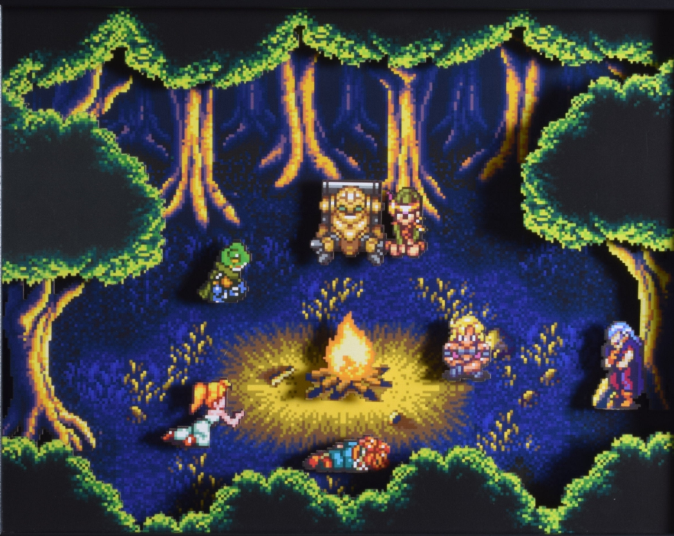



# **COMPETITIVENESS**

Bo Tron Dao is a survival game which makes it different from similar retro games like Zelda in the same genre. Also, with the benefit of playing on android devices on the go. Unlike Zelda you don’t get weapons at the start of the game, instead you have to collect them by avoiding guards and other animate objects like bats.